Business Requirements Document (BRD)  
For Barcodes,Inc.

|  |  |
| --- | --- |
| Project Manager: | Haresh Raisinghani |
| Client name | Barcodes,Inc. |
| Date submitted: | TODAY |
| Project Sponsor: | **Dan Nettesheim** |
| Business Analyst: | Anusha Radhakrishnan Iyer |
| Filename: | **BRD- web Based Solution – V.0.1 (Draft Version)** |
| VERSION: | 0.1 |
| Last Edit: | 11/28/2023 8:47:00 PM by |
| Last Author’s Comments: |  |

Table of Contents

**Business Requirements Document (BRD) For [JVMH INFOTECH] 1**

**Table of Contents 2**

**Section Zero: Instructions for the document or Positioning of the Business Requirements Document 4**

**Section One: Glossary 7**

**Section Two: Project Scope and Objectives Summary 8**

**Section Three: Technical Stack or Platform 9**

**Section Four: Intended Audience / Stakeholder Register 10**

**Section Five: Decision Making and Approval Process for the Business Requirements Document (For Audit Purpose only)** **12**

**Section Six: Framework or Methodology – (For Audit Purpose only)** **13**

**Section Seven: Background, Historical, and Prior Project Information with the client** **14**

**Section Eight: Requirements: ( What the Client Wants)** **15**

**Section Nine: Features or Functionalities of the Software 1****7**

**Section Ten: RBAC – Role Based Access Control- User Class Profiles and Key Delegations** **18**

**Section Eleven: Additional Information Regarding Functional Requirements Related to Output and Reporting** **19**

**Section Twelve: Flowchart – As is or To Be Process | Current State or Future State of the process | Conceptual Data Model | Process Flow |** **20**

**Section Thirteen: Non-Functional Requirements (NFR)** **22**

**Section Fourteen: Assumptions, Dependencies, and Constraints (Basic Business Rules- to be shared by SME)** **26**

**Section Fifteen: Project Risks** **27**

**Section Sixteen: Alternate Solution Options (Platform and Components)** **28**

**Section Seventeen: Change Request Process** **29**

**Section Eighteen: Document Revision Log** **30**

**Section Nineteen: Annexures / Any Additional Document** **31**

**Section Twenty: Approval / Sign-off** **32**

Section Zero: Instructions for the document or Positioning of the Business Requirements Document

## The Goal: Common Understanding Through Structured Business Analysis and a Standard Business Requirements Document

The Business Requirements Document is a major deliverable representing the achievement of the Business Analysis milestone in a typical project management methodology. As such it requires formal review and sign off by the Client Acceptor (representing the interests of business area stakeholders). Under normal circumstances, the Business Requirements Document is created by the Senior Business Analyst delegated to a project.

This Business Requirements Document template conforms to industry best practices in business analysis, and is the primary tool for structuring requirements-gathering activities. Interim feedback loops and approvals for Business Requirements Document sections are achieved in an iterative manner, as requirements become clear over successive meetings with project stakeholders, primary and secondary users. This facilitates the final review and approval of the overall document, which by then will contain “no surprises”.

## A Word of Caution about Removing/Adding Sections

Do not arbitrarily add or remove sections within your Business Requirements Document. To do so raises the risk of diluting the standard, as future teams may look to your documents for guidance in building their own reports. That being said, please use the following guidelines.

**Adding Sections –** While all project Business Requirements Documents begin with the standard template sections, the unique nature of each project may require additional sections and information. These are organized as Appendices.

**Removing Sections –** Since the Business Requirements Document template has been designed as a comprehensive study, removal of specific sections of the standard template is not recommended. Doing so represents requirements detail that will not be covered, and therefore can create project risk. Whoever authorizes removal of standard sections is accountable for ownership of that risk, and any consequences that emerge as a result. This is a key point that must be understood by all members of the project team. Document the sections that have been removed, and under whose direction, within the Risk section of the Business Requirements Document.

## Different Types of Requirements

Functional requirements can only be derived following elicitation and documentation of business and user requirements. The distinctions between these different requirements levels are important.

1. **Business Requirements 8.1** – place the business at the center of focus, and tie the project to documented regulatory, strategic, tactical and operational goals. If you are developing products or services for sale, customer requirements will also need to be documented. Customer requirements are covered off at a high level in this section, then in detail under User Requirements.
2. **User Requirements** **8.2 & 8.3** – place the user at the center of focus, and describe, with Flowcharts, Use Case Diagrams, Use Case Scenarios, Line of Vision and other process models, the “to be” user experience with the new system. In some cases, especially where business processes are being modified, it may also be necessary to document the “as is” state of user experience with the current system.
3. **Functional Requirements 9**– place the proposed system at the center of focus, and provide a prioritized list of capabilities the system must demonstrate in order to satisfy business and user requirements.
4. **Non-Functional Requirements 13** – refer to needs that must be fulfilled related to things like the user interface, access security, availability, robustness, system failure, integration, migration and documentation. As such, they do not deal with the actual functionality of the system, but represent key project success factors nevertheless.

## Prioritizing Requirements

Ensure that your users are aware of the following interpretations regarding the prioritization of requirements **(using the Moscow Technique)**

* **Must Have** – will be included in this release. These items represent core functionality and must be present. Absence of any Must Have functionality represents project failure.
* **Should Have** – will be included in this release provided all Must Have requirements have been met and sufficient project resources and time remain.
* **Could Have** – will be included in this release provided all Must Have and Should Have requirements have been met and sufficient project resources and time remain.
* **Ranking = M-Mandatory; D-Desirable; F- Future**

## Risk Response Strategies

**Note** – Balance brevity with completeness, quality with quantity. You cannot document everything down to the tiniest details and thereby eliminate all project risk. The Project Sponsor needs to have sufficient understanding to create an Acceptable Level of Risk in proceeding. This will vary based on project importance and urgency, as well as the business environment within which your project lives.

Imagine you are planning to go on a vacation in Asia together with your friend. Let's review some of the common risks that might take place, and your possible responses to these. There are four risk response strategies for negative risks, also known as threats:

* **Mitigation** - mitigating a risk means reducing the impact of a risk event on your project. For example, you might be planning to travel to the airport by train, but will also research **alternative options** in case there are planned rail works on the day of your travel.
  + **Acceptance** - accepting a risk means simply dealing with any of its consequences. For example, you know that your boss might not approve your vacation; however, you decide to purchase non-refundable plane tickets anyway because the price is too good. While this is the riskiest strategy out of four, it might be a wise choice if the probability of a risk is very low and the costs of mitigation are high.
  + **Avoidance -** avoiding a risk means reducing the probability of it happening to zero. Usually, this includes making some adjustments to the original project plan. For example, you are warned by your travel agent about an increased risk of malaria in Cambodia, so you decide not to go there at all, and visit Vietnam instead.
  + **Transferring**- transferring a risk means shifting the responsibility for dealing with risk event consequences to someone else. For example, in case you are worried that your luggage will be lost during the flight, you can purchase travel insurance, so that in the event of the luggage actually being lost, the risk will be transferred to the insurance company, from whom you would receive compensation.

## Version Control of the Document

**Examples**

**Document Name-Project Name- Version Number**

BRD-E-Commerce website-v.0.1-Draft Version

Section One: Glossary

This is the glossary

|  |  |
| --- | --- |
| **Term /Acronyms** | **Definition** |
| Batch Processing | To perform a task or change multiple items all at once, without manual repetition. |
| Brick-and-Motor | A retail business with a permanent physical location |
| Category | A group of products that have something in common |
| admin | In software, a user role with full administrator privileges to manage all functionality. |
|  |  |

A glossary can help ensure that readers have a collective understanding of the language and concepts used in a document by providing clear and accurate definitions for key terms. This can be particularly helpful in fields that use specialized or technical language, such as science, medicine, or engineering

**Section Two: Project Scope and Objectives Summary**

|  |
| --- |
| Project Scope and Objective:  The scope of this project is to deliver an E-commerce website to company Barcodes,Inc.(Chicago,IL) so that they could market to clients within the retail industry. |

* Is there a vision associated with this work?
* What is the high-level objective?
* What business area is the project for?
* Does the project cross into other areas?
* What are we trying to accomplish?
* Why does it make sense to do this work?
* What is the expected timeframe? Best case? worst case?
* What will the deliverables look like?
* What would a successful project look like?
* Who is likely to be the sponsor?
* What potential hurdles may there be?
* Are there any metrics or measures?
* What is the business reason for doing this work?
* Will this work be a stand-alone system or a component in a bigger system?
* What are the potential benefits of this work?
* Who is the customer?
* What is not included in the scope?

**Section Three: Technical Stack or Platform**

|  |  |
| --- | --- |
| **Solution (delivered to the client)** | **Technology Notes (on which platform)** |
| E-commerce Website | Adobe Magento V.2 |

Technology stack is important because you use it to build a software program. Therefore, do not underestimate the nature of research and analysis to choose the right tool. The wrong choice of technology can cost you money, time, and other valuable resources on your project

* **Refer/ Consult / connect with the Technical Team / Developer for Details of this section**
* What Technology are we using to deliver this software to the client
* On what platform will this application reside?
* Is there any history as to why this application exists?
* On what platform we are saving the Data?
* Any Legal and compliance (Internal) Rules apply for this project
* Will the existing infrastructure support this work?
* Is this work in line with our technology standards?

**Section Four: Intended Audience / Stakeholder Register**



Attach the Stakeholder register here

* Who will be the readers of this BRD?
* Who will be responsible for approving this BRD?
* What are their organizational titles?
* What are their roles?
* Is an org chart available?
* Who are the key stakeholders?
* What are their titles?
* Who will provide interim approval?
* Who is the single client acceptor?
* Are there any cultural issues to be aware of?
* Are there any personality issues to be aware of?
* Is there any reason this project would get resistance? If so, from who?

**Section Five:** **Decision Making and Approval Process for the Business Requirements Document (For Audit Purpose only)**

|  |  |
| --- | --- |
| Decision & Approval Process Making Process | Anusha Radhakrishnan Iyer anuriyer123@gmail.com  Haresh Raisinghani-jvmh.consulting@gmail.com  Dan Nettesheim-xxxx@barcodes.com |

**Section Six: Framework or Methodology – (For Audit Purpose only)**

1. Magneto

## Section 6.1 – Overall Project Management Approach

|  |
| --- |
| * Projects are managed in accordance with industry best practices, following the disciple of the PMI model of proper project management. * Each project has a well-defined project plan which is managed from initiation to closure. * Outside resources, vendors and subcontractors are managed as an additional resource to the project plan. * Project management approach follows the knowledge areas of the **PMBOK / Prince2 / CSM / PSM / SAFe 5.1 / #ScrumStudy** |

## Section 6.2 – Business Analysis Approach

|  |
| --- |
| * The BA will serve as the liaison among stakeholders to elicit, analyze, communicate and validate requirements. * The BA helps understand business problems and opportunities and recommends solutions that enable the business to achieve its goals and objectives. * The BA will utilize the most appropriate means of gathering business requirements and assimilating those into system requirements. * Business Analysis approach follows the knowledge areas of the **BABOK/ CSPO / PSPO/ SAFe 5.1. / #ScrumStudy** |

**Section Seven: Background, Historical, and Prior Project Information with the client**

|  |  |
| --- | --- |
| **Background of the Client** | * Barcodes, Inc. is North America’s leading provider of barcode, mobile computing, and RFID solutions * Company object is to focus on the customer * Barcode provides   #Best value.  #Unmatched customer Service. |
| **History of your earlier projects with the Client** | N/A |
| **If yes, then list the projects done with the client earlier** | N/A |

Have there been any previous efforts to accomplish this work?

Was there a previous project?

If so, are there records of it? (Diagrams, documentation, etc.)

If so, who was involved?

Is there any historical info that would be helpful?

Are there any other projects that are related to this work?

**Section Eight: Requirements:  
( What the Client Wants)**

## Section 8.1 – Regulatory Requirements

|  |  |
| --- | --- |
| ID | Regulation / Policy |
| 8.1.1 | E-commerce –Data Protection and Privacy Laws |

## Section 8.2 **– Business Requirements** relating to Strategic Goals (Organization Level)/ EPICS / PBI – (**Sponsor**)

|  |  |
| --- | --- |
| ID | Description |
| 8.2.1 | A web-based solution based on E-commerce platform |
| 8.2.2 | Streamline the operations of retail stores |
| 8.2.3 | Generate reports such as sales,customer reports. |

## Section 8.3 –**User Stories** – (10 user stories) – Journey of User and the System

|  |  |
| --- | --- |
| ID | Description **\*\*\* What the Client Wants** |
| 8.3.1 | As a User,  I want to search product  so that I can place order |
| 8.3.2 | As an admin  I want to have Reports on Daily Sales (executed and not in queue)  so that I can monitor the business transactions |
| 8.3.3 | As a user from marketing department,  I want the system to send automatic emails to my recipients  so that I can advertise my products |

**Section Nine: Features or Functionalities of the Software**

**What we deliver to the client**

**Ranking = M-Mandatory; D-Desirable; F- Future**

|  |  |  |  |  |
| --- | --- | --- | --- | --- |
| ID | **Requirement & Features -Magento** | **Priority Rank** | | |
| M | D | F |
| 9.1 | Flexible Product Catalog | M |  |  |
| 9.2 | Responsive Design and Customization |  | D |  |
| 9.3 | Robust Shopping Cart and Checkout |  |  | F |
| 9.4 | Multi-Store Management | M |  |  |
| 9.5 | SEO and Marketing Tools | M |  |  |
| 9.6 | Powerful Analytics and Reporting |  | D |  |
| 9.7 | Advanced Security Features |  | D |  |
| 9.8 | Scalability and Performance |  | D |  |
| 9.9 | Integration and Extensibility |  | D |  |
| 9.10 | Global Commerce Capabilities |  | D |  |

* What are the end user expectations?
* What are the “must haves”?
* What are the “should haves”?
* What are the “nice to haves”?
* Are there stages of completion?
* What are the key deliverables at each stage?
* Can the current process be graphically depicted?
* Is there a user wish list?

**Section Ten: RBAC – Role Based Access Control- User Class Profiles and Key Delegations**

## Section 10.1 **–** Primary Users (Data Entry)- **End Users with Read and write only rights**

|  |  |
| --- | --- |
| Name | Position |
| Pankaj | Manager or Supervisor |
| Mukesh | Inventory Manager |
|  |  |

## Section 10.2 - Secondary Users or Super User (Amend / Edit) **Read, Write and Edit Rights** – **Subject Mater Experts**

|  |  |
| --- | --- |
| Name | Position |
| Raj | Administrator |
| John | Manager or Supervisor |
|  |  |

## Section 10.3 – Admin Users - **Add or delete profile, Change Passwords** – IT Support

|  |  |
| --- | --- |
| Name | Position |
| Natasha | Customer Support Representative |
|  |  |

**Section Eleven: Additional Information Regarding Functional Requirements Related to Output and Reporting**

Ranking = M-Mandatory; D-Desirable; F- Future

|  |  |  |  |  |
| --- | --- | --- | --- | --- |
| ID | Requirement | Rank | | |
| M | D | F |
| 11.1 | Daily Sales Report | M |  |  |
| 11.2 | Customer Report | M |  |  |
| 11.3 | Yearly Report on Profit and Loss | M |  |  |
| 11.4 | Daily Financial Report | M |  |  |
| 11.5 | Weekly Financial Report |  | D |  |
| 11.6 | Monthly Financial Report |  | D |  |
| 11.7 | Yearly Financial Report |  | D |  |

* Are there any special reports needed?
* Are there any special queries?
* Are there management requirements?
* Are there scheduled operations?
* Are there repeated or sequenced operations?
* Are there key business rules that need documenting?
* Who gets the information that is generated?
* Is this info needed by a certain timeframe? weekly? monthly? yearly?

**Section Twelve: Flowchart – As is or To Be Process | Current State or Future State of the process | Conceptual Data Model | Process Flow |**

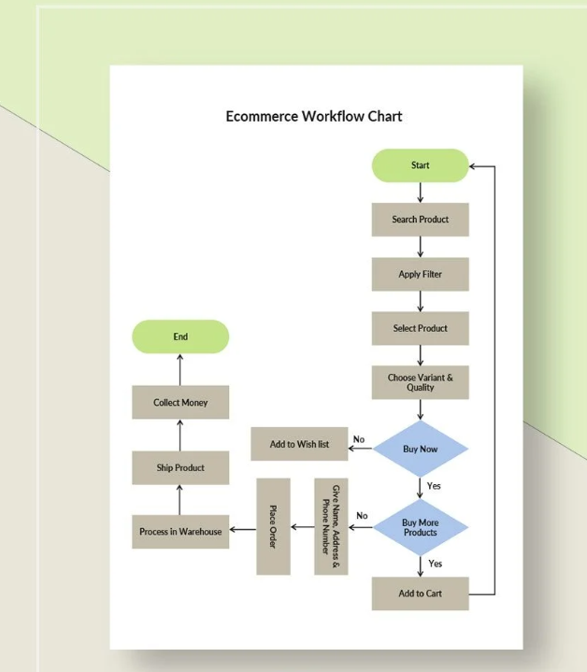

**Section Thirteen: Non-Functional Requirements (NFR)**

**Ranking or Priority = M-Mandatory; D-Desirable; F- Future**

## Section 13.1 **– Operational Environment / Production Environment**

Note: you need to ask these questions from the client and replace the questions with Answers

|  |  |
| --- | --- |
| ID | Requirement |
|
| 13.1.1 | * Integrated software with other systems, such as ERP (Enterprise Resource Planning) software, CRM (Customer Relationship Management) tools, payment gateways, shipping services, and more |
| 13.1.2 | * Accessible at all times, allowing customers to browse, shop, and make purchases around the clock. |

## Section 13.2 – Graphic User Interface Requirements- GUI

|  |  |  |  |  |
| --- | --- | --- | --- | --- |
| ID | Requirement | Rank | | |
| M | D | F |
| 13.2.1 | * Which Font do you want to use?Code 128", "Code 39", or "Libre Barcode 128" |  |  |  |
| 13.2.2 | * What Background you want to have in the software | M |  |  |
| 13.2.3 | * Where do you want Screen Logo to be displayed | M |  |  |
| 13.2.4 | * Where do you want User Name to be displayed? yes | M |  |  |

## Section 13.3 – User Access / Security Requirements

|  |  |  |  |  |
| --- | --- | --- | --- | --- |
| ID | Requirement | Rank | | |
| M | D | F |
| 13.3.1 | * SSO – Single Sign On | M |  |  |
| 13.3.2 | * Password Strength | M |  |  |
| 13.3.3 | * RSA Token | M |  |  |
| 13.3.4 | * Thumb Impression / Bio Metrics |  | D |  |

## Section 13.4 – Service Level / Performance / Capacity Requirements

|  |  |  |  |  |
| --- | --- | --- | --- | --- |
| ID | Requirement | Rank | | |
| M | D | F |
| 13.4.1 | * Number of Users of Softwares? |  | D |  |
| 13.4.2 | * Boot up Time? |  | D |  |
| 13.4.3 | * Speed of Transactions? |  | D |  |

## Section 13.5 – Data Requirements (input, correlative)

|  |  |  |  |  |
| --- | --- | --- | --- | --- |
| ID | Requirement | Rank | | |
| M | D | F |
| 13.5.1 | * Save the data at cloud server provided by AWS | M |  |  |
| 13.5.2 | * Data should be saved in txt format only | M |  |  |
| 13.5.3 | * Daily data should be saved in company’s Datawarehouse only | M |  |  |

## Section 13.6 – Business Continuity and Recovery Requirements

|  |  |  |  |  |
| --- | --- | --- | --- | --- |
| ID | Requirement | Rank | | |
| M | D | F |
| 13.6.1 | * Backup server of the data to be maintained at AWS / Oracle Server | M |  |  |
| 13.6.2 | * Recovery – Procedure – to be explained to the client | M |  |  |
| 13.6.3 |  |  |  |  |

## Section 13.7 – Integration / Migration / Transition Requirements

|  |  |  |  |  |
| --- | --- | --- | --- | --- |
| ID | Requirement | Rank | | |
| M | D | F |
| 13.7.1 | * Copy the data of old software and make it useable for new software | M |  |  |
| 13.7.2 | * Users should pass an exam or test to create their login credentials |  |  | F |
| 13.7.3 | * Na |  |  |  |

## Section 13.8 – Administrative Backup / Archive Requirements

|  |  |  |  |  |
| --- | --- | --- | --- | --- |
| ID | Requirement | Rank | | |
| M | D | F |
| 13.8.1 | * Back up should be taken every end of the day |  |  |  |
| 13.8.2 | * Back up should be saved or archived in company’s server |  |  |  |
| 13.8.3 |  |  |  |  |

## Section 13.9 -Expected Life Span Requirements

|  |  |  |  |  |
| --- | --- | --- | --- | --- |
| ID | Requirement | Rank | | |
| M | D | F |
| 13.9.1 | * The life span of software will be 12 months |  |  |  |
| 13.9.2 | * Subsequently, the license of the software can be renewed |  |  |  |

## Section 13.10 – Documentation Requirements

|  |  |  |  |  |
| --- | --- | --- | --- | --- |
| ID | Requirement | Rank | | |
| M | D | F |
| 13.10.1 | * User Manual |  |  |  |
| 13.10.2 | * Installation Instructions |  |  |  |
| 13.10.3 | * Trouble Shooting Guide or Support Guide for the software |  |  |  |

## Section 13.11 – Training Requirements

|  |  |  |  |  |
| --- | --- | --- | --- | --- |
| ID | Requirement | Rank | | |
| M | D | F |
| 13.11.1 | * We need to train all the Users | M |  |  |
| 13.11.2 | * Business Analyst to train the Users | M |  |  |

## Section 13.12 – Features under United Nations Disability Laws and Acts

|  |  |  |  |  |
| --- | --- | --- | --- | --- |
| ID | Requirement | Rank | | |
| M | D | F |
| 13.12.1 | * Any Functionality which is covered in the act | M |  |  |
| 13.12.2 | * Example Windows Ease of access Features – which are useful for the users of the below category | M |  |  |

Notes

Disability laws and acts are instruments through which countries abolish discrimination against persons with disabilities and eliminate barriers towards the full enjoyment of their rights and their inclusion in society. These laws and acts contribute to progress towards the implementation of the [Convention on the Rights of Persons with disabilities (CRPD)](https://www.un.org/development/desa/disabilities/convention-on-the-rights-of-persons-with-disabilities.html) in national legislation. Such legislation contributes also towards the achievement of the [Sustainable Development Goals (SDGs)](https://sustainabledevelopment.un.org/?menu=1300), and the pledge of the 2030 Agenda for Sustainable Development to leave no one behind.

Equal Employment Opportunity Commission regulations provide a list of conditions that should easily be concluded to be disabilities: deafness, blindness, an intellectual disability (formerly termed mental retardation), partially or completely missing limbs or mobility impairments requiring the use of a wheelchair, autism, cancer, cerebral palsy, diabetes, epilepsy, attention deficit hyperactivity disorder, Human Immunodeficiency Virus (HIV) infection, multiple sclerosis, muscular dystrophy, major depressive disorder, bipolar disorder, post-traumatic stress disorder, obsessive compulsive disorder, and schizophrenia.

* Americans with Disabilities Act of 1990
* United States - Rehabilitation Act of 1973 – As Amended Through P.L. 114–95, Enacted 10 December 2015
* Australian Disability Discrimination Act 1992
* United Kingdom - Equality Act 2010
* Canada - Services and Supports to Promote the Social Inclusion of Persons with Developmental Disabilities Act, 2008
* For More Details log on to <https://www.un.org/development/desa/disabilities/disability-laws-and-acts-by-country-area.html>

## Section 13.13 – Other Non-functional Requirements

|  |  |  |  |  |
| --- | --- | --- | --- | --- |
| ID | Requirement | Rank | | |
| M | D | F |
| 13.13.1 | * NA |  |  |  |
| 13.13.2 | * NA |  |  |  |
| 13.13.3 | * NA |  |  |  |

**Section Fourteen:   
Assumptions, Dependencies, and Constraints (Basic Business Rules- to be shared by SME)**

## Section 14.1 – Assumptions

|  |  |
| --- | --- |
| ID | **Assumptions or Business Rules, Client wants you to follow** |
|
| 14.1.1 | * The Daily Currency exchanges rates will be procured from Bloomberg Terminal |
| 14.1.2 | * All the data of the software has to be saved on local server of the client |
| 14.1.3 | * The currency the ATM will dispense will be USD only |
| 14.1.4 | * No 2 users can work on the same queue of the software |

## Section 14.2 – Dependencies – Process and System Dependencies

|  |  |
| --- | --- |
| ID | **Dependencies of the process or software** |
|
| 14.2.1 | * The Daily exchanges rates will be procured from Bloomberg Terminal |
| 14.2.2 | * Sales Functionality of the software is dependent on Inventory functionality of the software |

## Section 14.3 – Constraints / Technical Issues / Software challenges or Process challenges related to Software & Process **(Operational Challenges)**

|  |  |
| --- | --- |
| ID | **Issues the client is facing in the project Currently** |
|
| 14.3.1 | * Test environment not ready |
| 14.3.2 | * Minimum specification for installation of software not ready at client location |
| 14.3.3 | * Old data yet to be converted in to a readable format / compatibility issue with data |

**Section Fifteen: Project Risks**

|  |  |  |
| --- | --- | --- |
| ID | Item | Selected Risk Response |
| 15.1 | Technical issues | Transfer |
| 15.2 | Expanding requirements beyond the scope | Accept |
| 15.3 | Budget | Accept |

* Risk is an event which hasn’t occurred and can hamper the progress of the project,
* When a Risk occurs, it gets converted in to an Issue
* We BA’s report both Risk and Issues to our Project Managers

**Section Sixteen: Alternate Solution Options (Platform and Components)**

## Section 16.1 – Alternate Solution options offered to the client

|  |  |
| --- | --- |
| ID | Solution Options |
| 16.1.1 | * Google Platform |
| 16.1.2 | * Word Press |
| 16.1.3 | * Adobe Magento |
| 16.1.4 | * Wix or GoDaddy |
| 16.1.5 | * AWS |

## Section 16.2 – Solutions Selected by the client

|  |  |
| --- | --- |
| **ID** | **Solution Options** |
| 16.2.1 | * **Adobe Magento (Client Chose Magento V.2)** |
| 16.2.2 | * Maker Checker Rule or 4 eyes supervision |
| 16.2.3 | * SSO – Single Sign on |

**Section Seventeen: Change Request Process**

In future, if the client needs to add some additional requirements, the Client needs to follow the below mentioned process

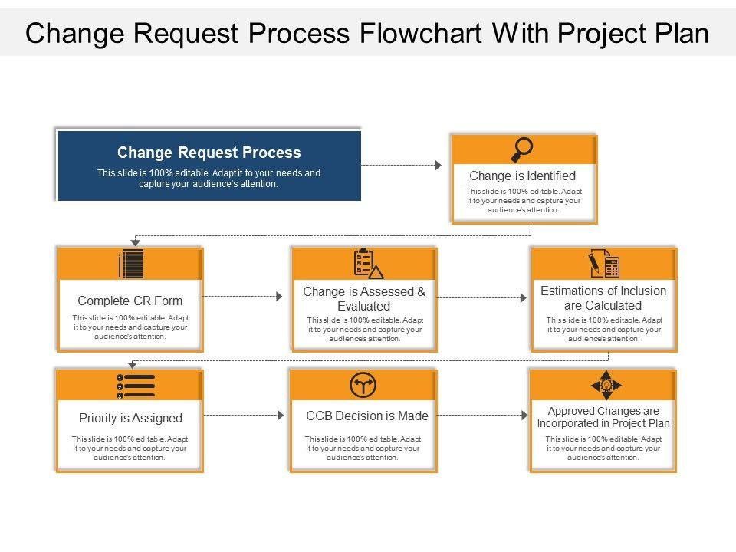

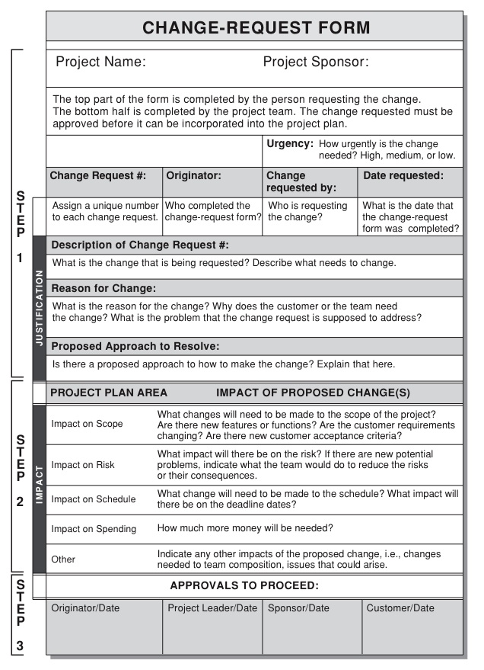

**Section Eighteen: Document Revision Log**

|  |  |  |  |
| --- | --- | --- | --- |
| Version | Date | Change Description | Author |
| V.0.1 | 1/10/24 | Draft | Anusha Radhakrishnan Iyer |

**Section Nineteen: Annexures / Any Additional Document**

|  |  |  |  |
| --- | --- | --- | --- |
| Name of the Document | Version | Document Description | Author |
| Reporting Matrix | v1.0 | Hierarchy chart | Dan |
|  |  |  |  |

Hierarchy chart



Section Twenty: Approval / Sign-off

This document has been approved as the official Business Requirements Document for the [name of project] project, and accurately reflects the current understanding of business requirements. Following approval of this document, requirements changes will be governed by the project’s change management process, including impact analysis, appropriate reviews and approvals, under the general control of the Project Plan and according to company policy.

|  |  |
| --- | --- |
| **Prepared by**  Anusha Radhakrishnan Iyer | 1/10/2024 |
| ________________________________________ | ________________ |
| **Business Analyst** | Date |
|  |  |
| **Reviewed by**  ________________________________________________  **Project Manager** | Date  __________________ |
| **Approved by** |  |
| ________________________________________ | ________________ |
| **Client Acceptor / Sponsor / SME** | Date |